

Marketing Management (MG-1002)
Topic: Case Study on Marketing: Top Edge Technologies
(Deliverable 1)

Submitted to: Dr. Syed Shujaat Ali Shah

Submitted by: Group 5
Muneeb ur Rehman (23L-0511)
Abdul Munam Aziz (23L-3019)
Hassan Mehmood (23L-0818)
Junaid Muhammad (23L-1014)
Ammar Noor Zia (23L-0558)

Section: 4A -BS CS Spring 2025
Submission Date: 17-04-2025

Project Summary/ Abstract:
Purpose of the Study
The objective of this report is to evaluate the marketing strategies of Top Edge Technology, a Multan-based product-oriented IT company with specialization in mobile game development. The research will investigate how the company generates revenue in game advertising, geo-pricing and digital marketing to generate revenue and has a presence in the global mobile gaming industry.

Methodology
The analysis is based on:
- Secondary research from the company’s official website and industry reports
- Observations of Top Edge’s product offerings and monetization strategies
- Application of marketing management concepts learned during the course

Key Findings
- Top Edge Technology effectively monetizes free-to-play games through strategic ad placement and region-specific ad pricing.
- The company faces key challenges such as user retention, internet dependency, and platform fragmentation.
- A data driven marketing approach and real-time performance analysis are central to its success.
- Certain markets (e.g., Iran, Russia) present difficulties due to economic and policy constraints.

Main Headings for Report Body:

- Introduction: Key Operations of Top Edge Technology
Discussed:
Companies’ information
Services they offer

- Industry Review
Discussed:
Global Software & Digital Products Sector
Mobile Gaming Industry Overview
Pakistani IT & Mobile Gaming Market
Challenges in the Mobile Gaming Industry

- Products, Services, and Brands by the Organization
Discussed:
Diverse Digital Services in ICT Sector
Core Brand Strength in Mobile Gaming
Revenue Driven by Genre-Based Game Strategy

- Marketing Department and Functions
- References

1. Introduction: Key Operations of Top Edge Technology:
Top Edge Technology is an emerging IT firm based in Multan, Pakistan. They are specialized in mobile game development, App development (in both Android and iOS), E-commerce and offer digital marketing solutions. They are a product-based company (focuses on designing, building and marketing its own digital products).
“We specialize in delivering cutting-edge innovations across various industries, focusing on developing a wide range of applications, games, and software tailored for diverse users. As a product-based company, we’re committed to creating solutions that make a real impact.” (Top Edge Technology, 2025).

Top Edge Technologies offers a wide range of digital services including:
App Development:
Custom apps for Android and iOS apps, developed to meet client requirements in business, education, entertainment and many other services.
Game Development:
Popular for creating interesting and games that are well defined with present day technologies and tools used to develop these games.
Software Development:
Developing responsive websites and web applications using latest frameworks.
Digital Marketing:
Offers services (Search Engine Optimization) SEO, social media management, content marketing and ad campaign services.
They also offer Ecommerce Solutions. Top Edge Technology has successfully launched several mobile applications mostly mobile games available on Android and iOS platforms. While rooted in Multan, Top Edge Technologies has extended its services to a global level.
We will be talking about one of their fundamental operations that revolves around earning revenue from ad by strategically designing game experiences meaning to perform to marketing through ads using there gaming or any other app platform. The company also uses detailed analysis to track user behavior like engagement of user with ad in order to redefine their approach.

2. Industry Review:
Top Edge Technology is a part of the larger software and digital products sector or industry, which also encompasses businesses that create applications, games, platforms and provides user end services. This industry has experienced rapid growth over the past twenty years due to more digital transformation and smartphones that is owned by almost every person at present.
In Pakistan, the IT industry has expanded at a fast rate, with software exports reaching to over $2.6 billion in 2023 (Statista, 2024). Several Pakistani firms, including Top Edge Technology, have made the transition from providing client-based services to creating their own digital offerings, which enable scalability, greater profit margins, and market penetration worldwide.

In the software sector, Top Edge Technology has made its place in the mobile gaming market which we are discussing in this report, one of the most rapidly growing segments of the world.
Discussing the global market, according to Wikipedia:
“As of July 2018, video games generated US$134.9 billion annually in global sales. In the US, the industry earned about $9.5 billion in 2007, $11.7 billion in 2008, and US$25.1 billion in 2010.The global games and services market is forecast to shrink 1.2% annually to $188 billion in 2022.” (Wikipedia – Video Game Industry)
Considering its future potential, according to precedence research,
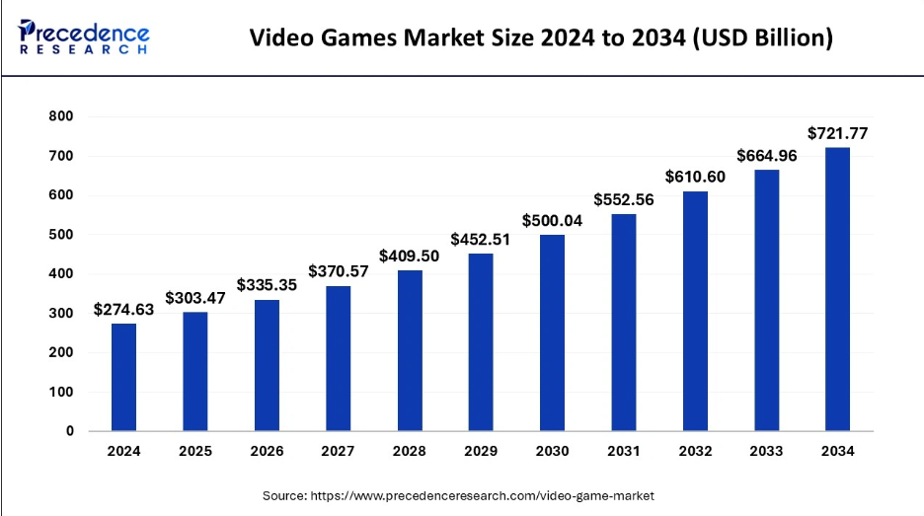
Discussing Pakistan alone, according to Statista, IT Services market in Pakistan is expected to reach US$2.63bn. and is projected to have a market volume of US$903.67m in 2025(Statista, 2024). Pakistan’s mobile gaming market is also growing, due to low-cost smartphones, cheaper mobile internet, and a large number of youth population.
Top Edge develops casual games which are:
- Designed for short, repeatable sessions
- Optimized for ad-supported monetization

Challenges in the Mobile Gaming Industry:
The mobile gaming industry, although is growing rapidly and at a very swift pace, it is still expected to face many challenges that impact both well-established game developers and newer firms like Top Edge Technology.
1. User Retention
After downloading retaining players or users is a great challenge. A large number of users quit the game after a very few numbers of plays that reduces the ad exposure and the revenue generated using those ads. By performing analysis, developers can find the point where user feels frustration, track places or points of frustration and improve game design to keep players engaged.
2. Ad Fatigue and User Experience
Mobile games usually use in-app ads to earn revenue. Nonetheless, too many or inappropriate ads can irritate users, causing negative reviews and uninstalls. The balance between monetization and user experience is a fragile one. Top Edge Technology for instance places ads strategically where users have to interact with them in order to move on but the strategy has to be watched out for lest it creates user annoyance.
3. Dependence on the internet:
Most games that rely on ads need a stable internet connection to serve ads and make money. This is a huge problem in areas where users lack or have poor internet connectivity. For instance, if a user downloads a game and plays offline, no ads are served meaning zero revenue from each session.
4. Fragmentations of Platforms:
With the emergence of alternative app stores like Samsung store, Huawei App etc. game developers now need to publish and maintain their games on multiple platforms. Each platform comes with its own technical requirements and store policies which increase complexity and cost in the development and marketing process.
5. Regional Regulations and Compliance
Every country has a unique or specific legal and technical requirements for mobile apps and games. For instance, launching a game in a country like China it involves extreme censorship and localization of apps meaning to involve a local company. Similarly, there are privacy laws in many countries so adding an extra cost for game developers.

3. Products/Services by the Organization
Top Edge Technology has strategically positioned itself within Pakistan’s fast-evolving digital product development ecosystem. Leveraging a product-based business model, the company minimizes dependence on third-party clients by managing the full life cycle of digital products—from idealization and development to monetization and distribution. This approach allows Top Edge Technology to control quality, scalability, and brand identity across its offerings.
A. General Services Portfolio
Operating within the Information and Communication Technology (ICT) domain, Top Edge Technology offers a robust portfolio of digital solutions designed to serve multiple verticals. These include:
- App Development: Native and cross-platform mobile applications tailored for sectors such as education, healthcare, retail, and entertainment. The focus is on intuitive UI/UX design, user engagement, and market-specific functionality.
- Software Development: Agile, saleable, and secure web and desktop solutions built using modern tech stacks such as React.js, Node.js, and Laravel, catering to both B2B and B2C markets.
- E-commerce Solutions: Fully managed online stores with built-in payment gateways, order tracking, and logistics integration. Emphasis is placed on conversion rate optimization (CRO) and mobile-first interfaces.
- Digital Marketing: End-to-end services that include search engine optimization (SEO), content marketing, social media growth, paid media, and influencer outreach aimed at enhancing digital visibility and customer acquisition.
These foundational services reinforce the company’s market presence and lay the groundwork for its core vertical—digital entertainment.
Say for example : -> Games Arena is an innovation by top edge technology
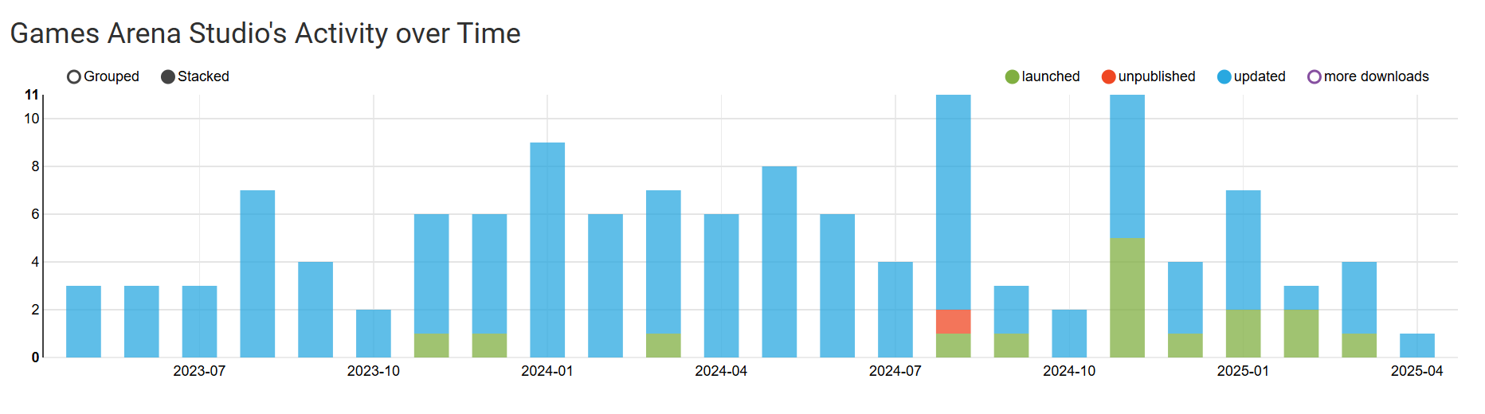
And it’s one the leading game (Circus balls) stats over the past few months:
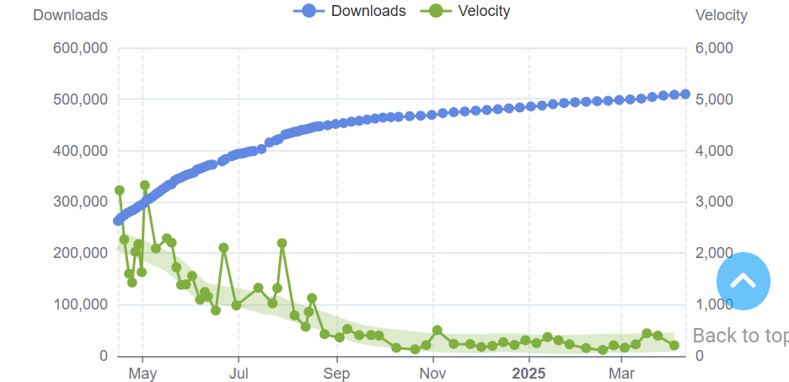
With over 500K users globally


B. Brand Focus – Digital Entertainment & Mobile Games
Top Edge Technology’s brand is most strongly associated with its offerings in the digital entertainment industry, particularly mobile game development. While secondary products such as in-game advertising solutions and limited-edition merchandise drops complement its ecosystem, the company’s core value proposition lies in its diverse and culturally resonant catalog of mobile games.
With a brand promise built on accessibility, innovation, and localized content, the organization markets itself as a one-stop platform for immersive and casual gaming experiences. These games are globally accessible via Android and iOS devices and are designed with:
- Premium monetization models: Core gameplay is free, with monetization achieved through rewarded ads, interstitial placements, and offer walls.
- Cultural customization: Games incorporate region-specific aesthetics and narratives, enhancing resonance with local audiences in Pakistan and emerging markets.
- Gamified UX/UI: Focused on short, addictive play sessions and smooth user on boarding, which increases session duration and retention.
By aligning product development with behavioral analytic, the company consistently refines user experiences to increase LTV (Lifetime Value) and ARPU (Average Revenue Per User).

1. Revenue Contribution by Game Genres
The company’s financial strength stems largely from its varied game genres. Among these, action games hold the largest share (30%) of the total revenue, followed by puzzle games at 25%, multiplayer formats at 20%, and RPGs at 15%.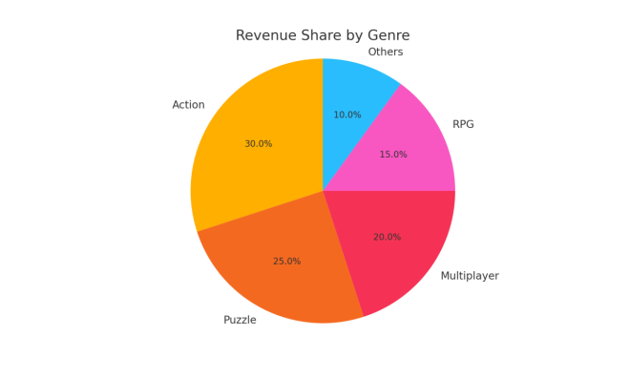
4. Marketing Department / Function
At Top Edge Technologies, the Marketing Department stands as a dynamic force behind the company’s growth, innovation, and brand communication. With a well-defined structure and a collaborative team, the department ensures effective execution of marketing strategies that align with business goals and resonate in the digital landscape.

Department Structure and Key Personnel
The overall direction of the department is guided by CEO Sardar Anser Ali (Anser Ali, 2025), who ensures that marketing strategies support the firm’s broader vision and technological mission.
The department comprises a skilled, cross-functional team:
- Fahad Safeer – Marketing Associate
Handles day-to-day marketing operations, social media coordination, and campaign implementation. Fahad plays a central role in managing promotional workflows and content deployment (Safeer, 2025).
- Rehan Hameed – Marketing Specialist
Focuses on market analysis, strategy development, and competitive research. His work directly contributes to shaping effective marketing campaigns and maximizing audience reach (Hameed, 2025).
- Zaid Abid & Mughees ul Hassan – Data Analysts
These two professionals form the analytical backbone of the department. They provide data insights, campaign performance reports, and consumer behavior analysis to inform marketing decisions (Abid, 2025; ul Hassan, 2025).
🔹 Special Mention – Mughees ul Hassan
Mughees played a key role in assisting our project team by answering our queries through LinkedIn chats and calls. His input provided us with essential insights regarding Top Edge Technologies and its operations.
- Graphic Designer –
Responsible for developing visual content for digital platforms, marketing collateral, and campaigns, enhancing the company’s brand identity.
- Aoun Abbas – Business Development Manager
Collaborates with the marketing team to align outreach strategies with lead generation and client acquisition efforts (Abbas, 2025).

Specialized Sub-Team Under Executive Leadership
A dedicated analytics and research-focused team operates under the leadership of Marketing Executive Lead Asad Bashir (Bashir, 2025):
- Team Members:
  - Zaid Abid – Data Analyst
  - Mughees ul Hassan – Data Analyst
This sub-unit focuses on high-level campaign analysis, strategic market research, and KPI tracking. Their findings help the broader team refine strategies and improve engagement.

Collaboration and Working Culture
Top Edge Technologies fosters a collaborative marketing environment, where creative and analytical minds work side-by-side. The department functions with an emphasis on innovation, adaptability, and open communication. Input from all departments, including business development and analytics, is welcomed to shape campaigns that are both impactful and aligned with organizational goals.

Vision and Future Goals
The marketing department is ambitiously working toward:
- Deepening digital engagement through newer channels and interactive formats.
- Leveraging data analytics for hyper-targeted campaigns.
- Enhancing brand visibility through thought leadership and storytelling.
- Fostering long-term relationships with clients through value-driven marketing.
With a talented team, supportive leadership, and a clear roadmap ahead, the marketing function at Top Edge Technologies is well-positioned to continue driving growth, visibility, and innovation in the tech industry.

Reference List:
-Top Edge Technology (2025). About Us. Available at:
https://topedge.pk/about [Accessed 13 Apr. 2025]
-Wikipedia. Video game industry – [online] at: https://en.wikipedia.org/wiki/Video_game_industry
-Statista. (2024) IT Services - Pakistan[online] Available at: https://www.statista.com/outlook/tmo/it-services/pakistan [Accessed 13 Apr. 2025].
-Statista. (2024) Mobile Games - Worldwide[online] Available at: https://www.statista.com/outlook/amo/media/games/mobile-games/worldwide [Accessed 13 Apr. 2025].
-Bunting, D. (2024). 6 Gaming Analytics Challenges and How To Solve Them. [online] Chaos Search. Available at: https://www.chaossearch.io/blog/solving-gaming-analytics-challenges [Accessed 14 Apr. 2025].
https://www.precedenceresearch.com/video-game-market
Anser Ali, S. (2025) LinkedIn profile. Available at: https://www.linkedin.com/in/sardar-anser-ali-5331611a/
Safeer, F. (2025) LinkedIn profile. Available at: https://www.linkedin.com/in/fahad-safeer-1b3243243/
Hameed, R. (2025) LinkedIn profile. Available at: https://www.linkedin.com/in/rehan-hameed-002405254/
Abid, Z. (2025) LinkedIn profile. Available at: https://www.linkedin.com/in/zaid-abid-525559233/
ul Hassan, M. (2025) LinkedIn profile. Available at: https://www.linkedin.com/in/mughees-ul-hassan-4b56b41b2/
Abbas, A. (2025) LinkedIn profile. Available at: https://www.linkedin.com/in/aaoownabbas/
Bashir, A. (2025) LinkedIn profile. Available at: https://www.linkedin.com/in/asad-bashir-b90262120/

